Instructions to Complete the Prince William Water Information Sheet in Excel Format

1. General Setup

General:

The engineer is required to completely fill out the Prince William Water Information Sheets and to submit them as part of the plan sets. The engineer has the option to complete the Prince William Water Information Sheets in either AutoCAD or Excel format. The Excel format is provided for the convenience of the user.

Excel Format & Page Layout:

Set the page layout to landscape.

Set the paper size to 24”x36” (Arch D)

Select a printer with a 24”x36” print out (Arch D).

Open Format:

Formulas and cells are purposely left unprotected. It may be necessary to overwrite the information in a cell. The cells are left unprotected as the engineer must certify the information. Hidden sheets that contain data, curves, and tables are locked and are not open for edit. Some cells default to #N/A because they are triggered by input from another field.

Sheet 1:

Prince William Water Information Sheet 1 contains drop down lists, auto-selections based on the user input, and preprogramed calculations. The input cells contain tips to aid data entry. Moving cells or clearing formulas in the cell could break links needed for calculations.

Sheet 2:

Prince William Water Information Sheet 2 contains a table for sanitary sewer design and a table for a lateral schedule. If laterals are fully profiled, completion of the lateral schedule is not required. Sheet 2 is not programmed for any calculations. The engineer is responsible to populate the tables with the needed information. Prince William Water will accept tables in a different format or arrangement provided all the requested information (e.g., columns) are provided.

Bugs or Errors:

Report “bugs” or errors to Ed Kovalchuk at [ekovalchuk@pwcsa.org](mailto:ekovalchuk@pwcsa.org).

1. General Plan Information



Purpose:

Information from these fields is directly imported into forms submitted to the Virginia Depart of Health Office of Drinking Water (VDH) and is part of the requirements to accept the project plans under Prince William Water’s Local Review Authority.

Input Type:

These fields require manual input.

Field Information:

|  |  |  |
| --- | --- | --- |
| FIELD: | INFORMATION | INFORMATION SOURCE |
| Project Plan Name: | Enter the name of the plans. | The plans. |
|  |  |  |
| Prince William County Plan Number: | Enter the plan number assigned by the County.  When a plan is submitted within the limits of an incorporated town, Retitle the field, “Prince William Water Plan Number,” and report the assigned Prince William Water plan number. | The plans. |
|  |  |  |
| Engineering Firm: | Enter the name of the engineer, surveyor, or architect company producing the plans. | The plans. |
|  |  |  |
| Project Location: | Provide a descriptive location of the site using the north, south, west, east, north-west, north-east, south-west, or south-east orientation relative to the nearest road intersection. Do not use GPINs or address references as these property identifiers change or get reassigned. | The plans. |
|  |  |  |

1. Service Area Information

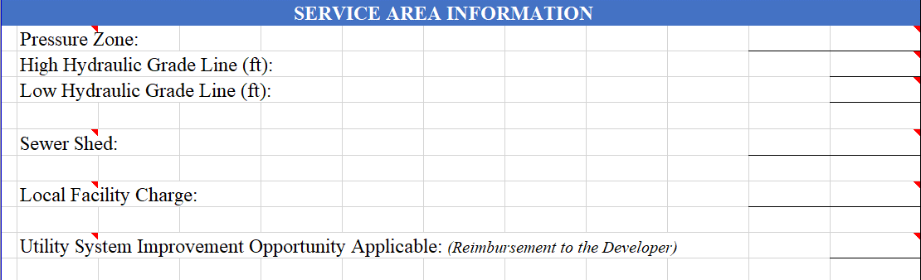

Purpose:

Pressure zone information is used to associate the project within a Prince William Water designated pressure zone. Sewer Shed information is used to associate the project within a Prince William Water designated sewer shed. Local Facility Charge designates that a project is subject to additional fees for water or sanitary sewer service. Utility System Improvement Opportunity designates that Prince William Water has requested betterments beyond the requirements of the Utility Standards Manual. This information is used Prince William Water internal reports.

Input Type:

Information is selected from predefined lists. Some fields are pre-populated based on the selection of the pressure zone. Pressure zone, sewer shed, and Local Facility Charge maps can be found as a reference map under web page for Prince William Water Standard Plan Sheets.

Field Information:

|  |  |  |
| --- | --- | --- |
| FIELD: | INFORMATION | INFORMATION SOURCE |
| Pressure Zone: | Select the pressure zone the project resides in. | Pressure zone maps |
|  |  |  |
| High Hydraulic Grade Line: | Information is automatically populated by the Pressure Zone section and is used to make calculations in other parts of the sheet. | Preprogrammed in the spreadsheet. |
|  |  |  |
| Low Hydraulic Grade Line: | Information is automatically populated by the Pressure Zone section and is used to make calculations in other parts of the sheet. | Preprogrammed in the spreadsheet. |
|  |  |  |
| Sewer Shed: | Select the sewer shed the project resides in. | Sewer shed maps. |
|  |  |  |
| Local Facility Charge: | Select the Local Facility Charge area the project resides in. | Local Facility Charge map. |
|  |  |  |
| Utility System Improvement Opportunity: | Select if applicable. | Prince William Water Policy § 41555 in USM Appendix I. |

1. Project Metrics

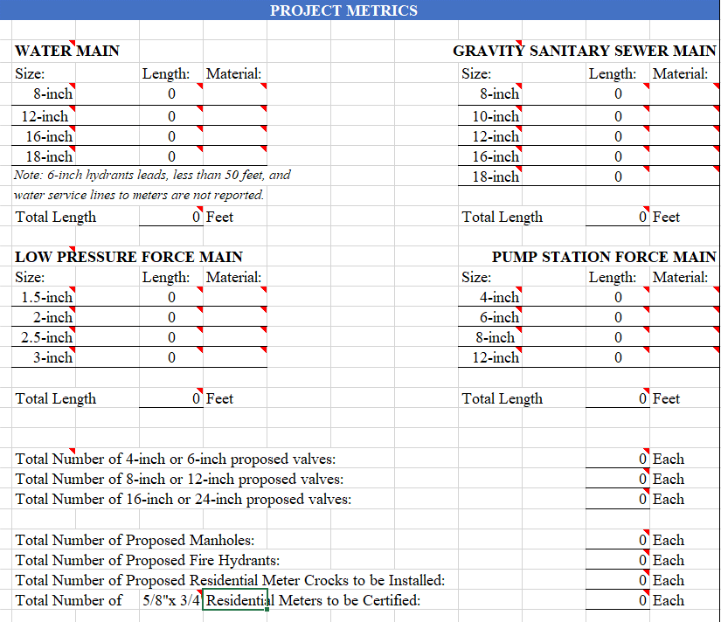

Purpose:

Quantities of the different water main sizes and materials are directly entered into forms submitted to Virginia Depart of Health Office of Drinking Water (VDH) and are part of the requirements to accept the project under Prince William Water’s Local Review Authority. Water main quantities are also used to assess various types of fees with rates specific to a water main at the time of plan permitting.

Sewer main, low pressure force main, and pump station force main quantities are used to assess various types of fees with rates specific to the type of asset at the time of plan permitting. Low pressure force main and force main quantities are not assessed TV Inspection fees. Quantities are matched with the Unit Price Sheet as a bondable item.

4.0 Project Metrics – Continued

Private gravity sanitary sewer minas are inspected by Prince William Water. Private gravity sewer main quantities are entered and identified in the Gravity Sanitary Ser Main table. Both Prince William Water and private sewer quantities shall be totaled together. Be advised that private low pressure force mains and private force mains are not inspected by Prince William Water; therefore, not reported in the project metric table.

The valve count is for inspection purposes and are matched with the Unit Price Sheet as a bondable item. Manholes and fire hydrants are matched with the Unit Price Sheet as a bondable item.

The number of water meter crocks to be installed is matched with the Unit Price Sheet as a bondable item. The number of meter crocks also helps identify if crocks are being installed for future use or if existing crocks are utilized from another project. The number of proposed metered accounts is reported to determine the number of new accounts that will be created with the plan.

Input Type:

Pipe lengths and unit quantities are manually inputted. The pipe sizes and material are selected from predefined lists.

4.0 Project Metrics – Continued

Field Information:

|  |  |  |
| --- | --- | --- |
| FIELD: | INFORMATION | INFORMATION SOURCE |
| Size: | The pipe sizes are selectable from a list based on the different pipe sizes specified in the plans.  Note: 6-inch hydrant leads, less than 50 feet, and water service lines to meters are not reported. | The plans. |
|  |  |  |
| Length: | The proposed pipe lengths are reported for the different sizes specified in the plans. **All reported lengths shall be rounded up to the fullest linear footage**. Factional lengths are not acceptable.   * Water, low pressure force main, and force main lengths are calculated using the linear footage from the waterline profiles. * Gravity sanitary sewer main lengths are calculated by summing the lengths of pipe used to compute the slope. | The plans. |
|  |  |  |
| Material: | The pipe materials are selectable from a list based on the different pipe materials specified in the plans. | The plans. |
|  |  |  |
| Total Length: | Pipe totals are automatically summed and used to populate Pipe Quantity Summary. | The plans. |
|  |  |  |
| Number of Proposed Valves: | Quantities of the different valve sizes specified in the plans are manually inputted. | The plans. |
|  |  |  |
| Number of Manholes: | The number of proposed manholes specified in the plans is manually inputted. | The plans. |
|  |  |  |
| Number of Hydrants: | The number of proposed hydrants specified in the plans is manually inputted. | The plans. |
|  |  |  |
| Meter Crocks to be Installed: | The number of proposed meter crocks specified in the plans is manually inputted. | The plans. |
|  |  |  |
| Meters to be Certified: | The number of residential metered accounts specified in the plans is manually inputted. This field is not used for multifamily or non-residential accounts. | The plans. |

1. Pipe Totals for Fee Calculations

5.0 Pipe Totals for Fee Calculations

* 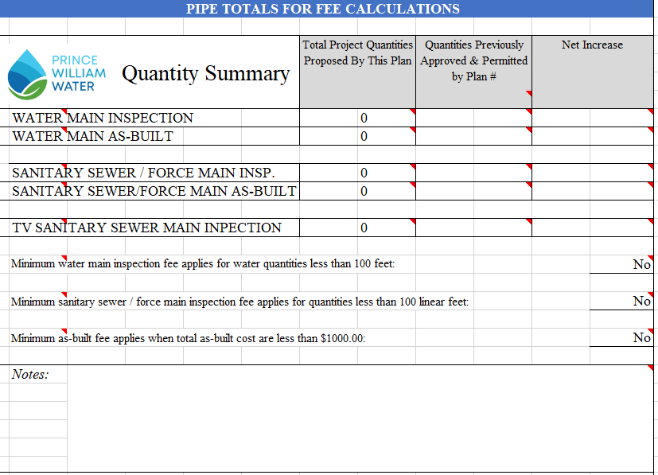

Purpose:

Quantities of different asset types are automatically totaled from Project Metrics and are used by Prince William Water Utility Services to assess various types of fees (e.g., plan review, inspection, TV inspection, and as-built) at the time of plan permitting.

* Minimum water main inspection fees apply when inspection services from Prince William Water are required, but pipe totals are less than 100 feet.
* Minimum sanitary sewer / force main inspection fees apply when inspection services from Prince William Water are required, but pipe totals are less than 100 feet.
* Minimum as-built fees apply the total as-built cost are less than $1000.00.
  + $1.20 per linear foot is the as-built fee rate for water main.
  + $1.80 per linear foot is the as-built fee rate for sanitary sewer / force main.

When design changes are submitted as a plan revision, total quantities represented by the plan revision are compared to quantities in the last permitted plan. Net increases are subject to additional inspection, TV inspection, and as-built fees.

1. Pipe Totals for Fee Calculations - Continued

The full sum of Prince William Water and private gravity sewer mains shall be used for Sanitary Sewer Inspection and TV Sanitary Sewer Main Inspection in the table. Prince William Water will not as-built private gravity sewer; therefore, the pipe totals for Sanitary Sewer / Force Main As-built will need to be manually adjusted excluding quantities for private gravity sewer.

Field Information:

|  |  |  |
| --- | --- | --- |
| FIELD: | INFORMATION | INFORMATION SOURCE |
| Total Project Quantities: | Pipe totals are automatically summed from Project Metrics. | Preprogrammed in the spreadsheet. |
|  |  |  |
| Quantities Previously Approved & Permitted by Plan: | Pipe quantities are manually inputted from previously approved and permitted plans. | Previously approved and permitted plans. |
|  |  |  |
| Net Increase: | The difference in pipe quantities are manually calculated and inputted. Do not report negative numbers. | User calculated. |
|  |  |  |
| Minimum water main inspection fee applies for water quantities less than 100 feet: | Select yes or no. A minimum inspection fee is applicable when inspection service must be rendered for work on water features (e.g. wet tap, service tap, etc.) that impact Service assets or the quantities are less than 100 feet. | User selected. |
|  |  |  |
| Minimum sanitary sewer / force main inspection fee applies for quantities less than 100 linear feet: | Select yes or no. A minimum inspection fee is applicable when inspection service must be rendered for work on sanitary sewer features (e.g. lateral connection, etc.) that impact Service assets or the quantities are less than 100 feet. | User selected. |
|  |  |  |
| Minimum as-built fee applies when total as-built cost are less than $1000.00: | Select yes or no. Minimum as-built fees will apply when quantities of combined water and sanitary sewer assets total less than $1000. Minimum as-built fees do not apply for a plan revision if the original plan has not already been as-built by Prince William Water and there is no net increase in quantities. | User selected. |
|  |  |  |
| Notes: | Miscellaneous information is provided when clarification is needed. | User supplied. |

1. Thrust Restraint Assumptions for Calculations

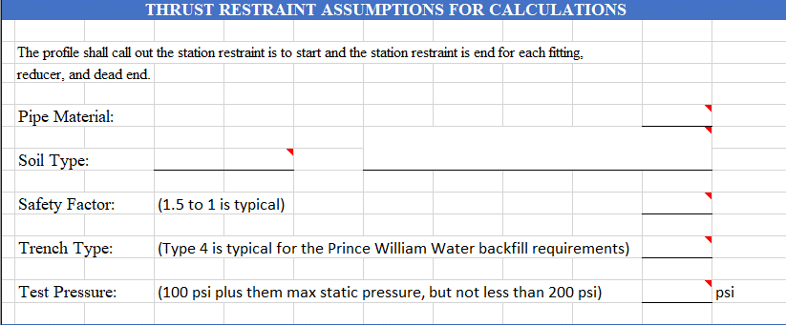

Purpose:

This table is used to disclose assumptions used to calculate pipe restraint specified in the water main profiles. Prince William Water uses this information to check specified restraint in the profiles using EBAA Iron’s online Restraint Length Calculator.

Field Information:

|  |  |  |
| --- | --- | --- |
| FIELD: | INFORMATION | INFORMATION SOURCE |
| Pipe Material: | The pipe materials are selectable from a list based on the different pipe materials specified in the plans. | The plans. |
|  |  |  |
| Soil Type: | The soil types are selectable from a list based on the USGS standards. | Geotechnical Report. |
|  |  |  |
| Safety Factor: | The safety factor is selectable from a list. More conservative safety factors can be selected but a minimum of 1.5 to 1 is required. | Design Engineer selects. |
|  |  |  |
| Trench Type: | Trench type is selectable from a list. More conservative trench type selection are permitted. | Prince William Water’s Utility Standards Manual. |
|  |  |  |
| Test Pressure: | Test pressure is selectable from a list. If necessary the test pressure field can be manually overwritten. | Prince William Water’s Utility Standards Manual and hydraulic model. |

1. Designation of the Responsible Party & As-built Release of Plans

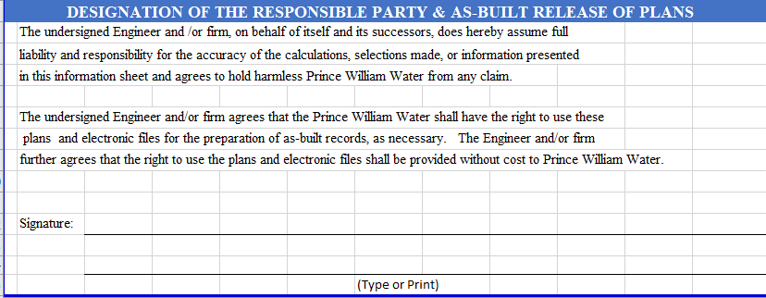

Purpose:

The engineer is responsible to certify all information in the Prince William Water Information Sheet. In addition, a release of the plans is required to prepare as-built records of the utilities.

1. Hydraulic Summary

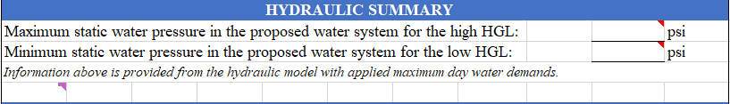

Purpose:

It is also used to check for compliance to Prince William Water design requirements.

Field Information:

|  |  |  |
| --- | --- | --- |
| FIELD: | INFORMATION | INFORMATION SOURCE |
| Maximum Static Water Pressure: | Manual input required. Mark N/A if a water system is not proposed | Hydraulic model. |
|  |  |  |
| Minimum Static Water Pressure: | Manual input required. Mark N/A if a water system is not proposed. | Hydraulic model. |

1. Fire Flow Summary

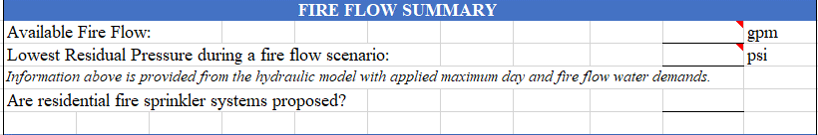

Purpose:

Information in these fields is directly imported into forms submitted to Virginia Depart of Health Office of Drinking Water (VDH) and is part of the requirements to accept the project plans under the Prince William Water’s Local Review Authority. It is also used to check for compliance to fire flow requirements and Prince William Water pressure requirements. Residential fire sprinkler systems must be disclosed to Prince William Water as larger meters and services lines may be required.

Field Information:

|  |  |  |
| --- | --- | --- |
| FIELD: | INFORMATION | INFORMATION SOURCE |
| Available Fire Flow: | Manual input required. Mark N/A if fire flow is not a requirement of the project. | Hydraulic model. |
|  |  |  |
| Lowest Residential Pressure During a Fire Flow Scenario: | Manual input required. Mark N/A if fire flow is not a requirement of the project | Hydraulic model. |
|  |  |  |
| Are residential sprinkler systems proposed: | Select yes or no. | Proffers or developer’s housing product. |

1. Delivery Pressure Summary



Purpose:

Engineers are to set the finished floor elevations relative to the high and low hydraulic grade line of the pressure zone to comply with the applicable codes. Where the finished floor elevations at the building entrance cannot be set to meet the applicable code, the engineer shall specify the needed mitigation (e.g., private water booster pump, pressure reducing device).

Field Information:

|  |  |  |
| --- | --- | --- |
| FIELD: | INFORMATION | INFORMATION SOURCE |
| High Hydraulic Grade Line: | Automatically populated by selection of the pressure zone. | Preprogrammed in the spreadsheet. |
|  |  |  |
| Lowest Finished Floor: | Manual input required. Leave blank if a building or lot is not proposed with the plans. | The plans. |
|  |  |  |
| Estimated High Static Pressure: | This is a self-calculating field. No manual input is required. | Preprogrammed in the spreadsheet. |
|  |  |  |
| Low Hydraulic Grade Line: | Automatically populated by selection of the pressure zone. | Preprogrammed in the spreadsheet. |
|  |  |  |
| Highest Finished Floor: | Manual input required. Leave blank if a building or lot is not proposed with the plans. | The plans. |
|  |  |  |
| Estimated Low Static Pressure: | This is a self-calculating field. No manual input is required. | Preprogrammed in the spreadsheet. |

1. Delivery Pressure Summary - Continued



Purpose:

The engineer is to specify which lots require water booster pumps or pressure reducing devices to meet design requirements for delivery pressure. This table may be extracted and expanded in a separate sheet if necessary.

Field Information:

|  |  |  |
| --- | --- | --- |
| FIELD: | INFORMATION | INFORMATION SOURCE |
| Booster pumps and pressure reducing devices are not needed: | Check box is marked if the statement is true. | International Residential Code |
| Booster pumps and pressure reducing devices are needed: | Check box is marked if the statement is true. | International Residential Code |
|  | | |
| ***The following is to be reported if booster pumps and pressure reducing valves are needed.*** | | |
| Lot or Building ID: | Manual input is required | The plans. |
| Floor elevation: | Manual input is required. | The plans. |
| High hydraulic grade line: | Automatically populated by selection of the pressure zone. | Preprogrammed in the spreadsheet. |
| Low hydraulic grade line: | Automatically populated by selection of the pressure zone. | Preprogrammed in the spreadsheet. |
| Estimated high pressure: | This is a self-calculating field. No manual input is required. | Preprogrammed in the spreadsheet. |
| Estimated low pressure: | This is a self-calculating field. No manual input is required. | Preprogrammed in the spreadsheet. |
| Booster pump needed: | This is a self-calculating field. No manual input is required. | Preprogrammed in the spreadsheet. |
| Pressure reducing device needed: | This is a self-calculating field. No manual input is required. | Preprogrammed in the spreadsheet. |

1. AWWA Water Demand Estimate and Meter Sizing Using Fixture Values



Purpose:

The form has been built using AWWA Manual 22 standards to automatically calculate the meter size from a list of inputted fixtures. A fixture list and meter sizing calculations are required for multi-dwelling and non-residential uses. A separate fixture list shall be provided in the plan set for each proposed meter. It may be necessary for the engineer to copy the information in a different plan sheet.

1. AWWA Water Demand Estimate and Meter Sizing Using Fixture Values – Continued

Field Information:

|  |  |  |
| --- | --- | --- |
| FIELD: | INFORMATION | INFORMATION SOURCE |
| Building Identifier: | This requires manual input and is necessary to match to the fixture list to a specified meter in the plans and meter schedule. | The plans. |
| Multi-Dwelling Residential or Non-Residential: | The designation is used to match to one of two AWWA demand curves that determines the estimate peak water demand for a given fixture value.  Prince William Water allows the use of a Low Demand curve for non-residential uses when tank toilets are proposed. | Zoning and the plans. |
| Maximum Static Water Pressure: | The maximum static pressure at the meter location is selected from a list for the purpose to determine the needed pressure adjustment factor. | Hydraulic model. |
| Number of Fixtures: | Manual input is required. The user must report or estimate the fixtures that will be installed in the building to estimate the water demand in order to specify the needed meter size. This action cannot be deferred. This information can be updated and resubmitted to Prince William Water as a field revision prior to meter certification. No reductions are permitted after an account is certified. | Architect plans and/or plumbing plans. In absence of these plans the owner’s estimate will suffice. |
| Combined Fixture Value: | This field automatically sums the calculated fixture values. | Preprogrammed in the spreadsheet. |
| Demand (gpm) From AWWA Curve: | The spreadsheet selects the water demand from the appropriate AWWA demand curve using the combined fixture value. | Preprogrammed in the spreadsheet. |
| Pressure Adjustment Factor: | This factor is automatically selected based on the selected maximum static water pressure. | Preprogrammed in the spreadsheet. |
| Adjusted Demand: | This field automatically multiplies the estimated demand by the pressure factor. The factor adjusts the demand, calculated for an operating pressure of 60 psi, to the maximum operating pressure that will be applied at the meter location. | Preprogrammed in the spreadsheet. |
| Irrigation Demands: | Manual input is required for irrigation demands that must be factored into the meter sizing. | Design Engineer inputs water demand from irrigation that will occur simultaneously with normal water use. |
| Water Demand for Equipment: | Manual input is required for equipment having water demands that must be factored into the meter sizing. | Design Engineer inputs water demand from equipment that will occur simultaneously with normal water use. |
| Total Estimated Peak Flow: | This field automatically sums the applicable water demands and is used to size the meter. | Preprogrammed in the spreadsheet. |
| Required AWWA Meter Size: | This field automatically selects the meter size based on required total calculated peak flow. | Preprogrammed in the spreadsheet. |

1. Multi-Dwelling Meter Schedule

Purpose:

The Multi-Dwelling Meter Schedule is used by Prince William Water Utility Services to quote and invoice availability fees for the different meter accounts. Meters are sized for the estimated peak water demand calculated using AWWA M22 standards. Availability fees are assessed based the number of dwelling units.

Field Information:

|  |  |  |
| --- | --- | --- |
| FIELD: | INFORMATION | INFORMATION SOURCE |
| Building Identifier: | This field requires manual input and is necessary to match a meter for a specific building shown in the plans to the meter schedule. | The plans. |
| Building Address: | This field requires manual input and is to be provided if known. If a new address is being recreated and is unknown, data entry may be deferred. | PWC Address listing. |
| Meter Use: | This field requires manual input and typically matches the building use or another dedicated purpose (e.g. irrigation). Information is used to verify that the correct account type is selected. | The plans. |
| Account Type: | A selection is made from a list. The account type is used to determine the applicable number of ERUs and to calculate an estimated availability fee. | Design Engineer selects. |
| Number of Dwelling Units: | This field requires manual input and is used to determine the required number of ERUs to be purchased. | The plans. |
| Peak Demand: | This field requires manual input. The peak demand for the specific meter is calculated from a fixture list and AWWA M22 standards. | AWWA M22 standard. |
| ERU: | The spreadsheet automatically calculates the number of Equivalent Residential Units (ERU) based for a water & sewer account and the number of dwelling units. ERUs are automatically selected by the spreadsheet for water only accounts and the meter size. ERUs for sub-meter accounts are not applicable as capacity is not purchased with a sub-meter. If an ERU number generates, it must be manually set to zero. The estimated fee is based on the sub-meter size. | Preprogrammed in the spreadsheet. |
| Meter Size: | The meter size is automatically selected based on the peak demand. | Preprogrammed in the spreadsheet. |
| Meter Type: | The meter type is automatically selected based on the meter size. | Preprogrammed in the spreadsheet. |
| Non-Binding Estimated Availability Fee: | A non-binding estimated availability fee is calculated by the spreadsheet based on the account type and number of ERUs. This does not generate a full and complete estimate and is meant to disclose an order of magnitude of the cost for the reported information. | Preprogrammed in the spreadsheet. |

1. Non-Residential Meter Schedule

Purpose:

The Non-Residential Meter Schedule is used by Prince William Water Utility Services to quote and invoice availability fees for the different meter accounts. Meters are sized for the estimated peak water demand calculated using AWWA M22 standards. Availability fees are assessed based on meter size for meters up to and including 1.5-inch. Availability fees for 2-inch meters and larger are assessed based on the max month use; however, there is a ERU purchase of 12.

Field Information:

|  |  |  |
| --- | --- | --- |
| FIELD: | INFORMATION | INFORMATION SOURCE |
| Building Identifier: | This field requires manual input and is necessary to match a meter for a specific building shown in the plans to the meter schedule. | The plans. |
| Building Address: | This field requires manual input and is to be provided if known. If a new address is being recreated and is unknown, data entry may be deferred. | PWC Address listing. |
| Meter Use: | This field requires manual input and typically matches the building use or another dedicated purpose (e.g. irrigation). Information is used to verify that the correct account type is selected. | The plans. |
| Account Type: | A selection is made from a list. The account type is used to calculate an estimated availability fee. | Design Engineer selects. |
| Estimated Max Month Consumption: | This field requires manual input for 2-inch meters and larger. Information is used to determine the number of ERUs that must be purchased. The estimated consumption for 1.5-inch meters and smaller does not have to be reported as the ERU allotment is set by the Prince William Waters Developer Rates and Fee schedule. | Design Engineer and/or Developer. |
| Peak Demand: | This field requires manual input. The peak demand for the specific meter is calculated from a fixture list and AWWA M22 standards. | AWWA M22 standard. |
| ERU: | The spreadsheet automatically calculates the number of Equivalent Residential Units (ERU) based on the meter size for meters 1.5-inch or smaller. Manual entry is required for 2-inch meters or larger. The inputted number of ERUs for 2-inch meters or larger must match the estimated max month consumption. **ERUs are to be rounded up, if necessary, to a full ERU count.** Partial or fractions of an ERU will not be accepted. | Preprogrammed in the spreadsheet for meters 1.5-inch or smaller.  The Design Engineer must make a manual entry when required. |
| Meter Size: | The meter size is automatically selected based on the peak demand. | Preprogrammed in the spreadsheet. |
| Meter Type: | The meter type is automatically selected based on the meter size. | Preprogrammed in the spreadsheet. |
| Non-Binding Estimated Availability Fee: | A non-binding estimated availability fee is calculated by the spreadsheet based on the account type and number of ERUs. This does not generate a full and complete estimate and is meant to disclose an order of magnitude of the cost for the reported information. | Preprogrammed in the spreadsheet. |

1. Data Center Meter Schedule

Purpose:

The Data Center Meter Schedule is used by Prince William Water Utility Services to quote and invoice availability fees for the different meter accounts. Information is the same as the Non-Residential Meter Schedule with the exceptional of an allowable sewer only account for cooling applications.

Field Information:

|  |  |  |
| --- | --- | --- |
| FIELD: | INFORMATION | INFORMATION SOURCE |
| Building Identifier: | This field requires manual input and is necessary to match a meter for a specific building shown in the plans to the meter schedule. | The plans. |
| Building Address: | This field requires manual input and is to be provided if known. If a new address is being recreated and is unknown, data entry may be deferred. | PWC Address listing. |
| Meter Use: | This field requires manual input and typically matches the building use or another dedicated purpose (e.g. irrigation, cooling, etc.). Information is used to verify that the correct account type is selected. | The plans. |
| Account Type: | A selection is made from a list. The account type is used to calculate an estimated availability fee. | Design Engineer selects. |
| Estimated Max Month Consumption: | This field requires manual input for 2-inch meters and larger and meters used for a sewer only account. Information is used to determine the number of ERUs that must be purchased. | Design Engineer and/or Developer. |
| Peak Demand: | This field requires manual input. The peak demand for the specific meter is calculated from a fixture list and AWWA M22 standards for domestic use. | AWWA M22 standard. |
| ERU: | The spreadsheet automatically calculates the number of Equivalent Residential Units (ERU) based on the meter size for meters 1.5-inch or smaller. Manual entry is required for 2-inch meters or larger. Manual entry is also required for all meters associated with a sewer only account type. The inputted number of ERUs for 2-inch meters or larger must match the estimated max month consumption. | Preprogrammed in the spreadsheet for meters 1.5-inch or smaller.  The Design Engineer must make a manual entry when required. |
| Meter Size: | The meter size is automatically selected based on the account type and peak demand. | Preprogrammed in the spreadsheet. |
| Meter Type: | The meter type is automatically selected based on the account type and meter size. | Preprogrammed in the spreadsheet. |
| Non-Binding Estimated Availability Fee: | A non-binding estimated availability fee is calculated by the spreadsheet based on the account type and number of ERUs. This does not generate a full and complete estimate and is meant to disclose an order of magnitude of the cost for the reported information. | Preprogrammed in the spreadsheet. |