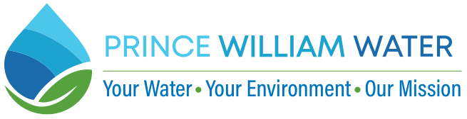

**FOR IMMEDIATE RELEASE**                                   CONTACT: Marcus Wilson

(703) 393-4407

[**mwilson@pwcsa.org**](mailto:mwilson@pwcsa.org)

**Prince William Water Releases 2024 Water Quality Reports**

WOODBRIDGE, VA **–** July 18, 2024– Prince William Water, formerly the Prince William County Service Authority, has released its 2024 Water Quality Report, providing important information about the source and characteristics of drinking water in its service area. The report is available on Prince William Water’s website at https://bit.ly/WQR-2024.

Data for each of Prince William Water’s five distribution systems – East, West, Hoadly Manor, Carter’s Grove, and Bull Run Mountain and Evergreen – is available in the Water Quality Report As noted in the report, our drinking water met all federal and state water quality requirements for calendar year 2023, which is the most recent regulatory period.

"We met or exceeded all federal and state water quality requirements for the calendar year 2023, the most recent regulatory period," said General Manager/CEO Calvin D. Farr, Jr., P.E. "This high standard aligns with our mission to protect public health and the environment by providing safe, dependable water and wastewater reclamation services to our community."

Except for drinking water in the Bull Run Mountain and Evergreen communities, the drinking water distributed by Prince William Water is sourced from the Potomac River, Occoquan Reservoir and Lake Manassas. While most of the drinking water Prince William Water provides to customers is treated at facilities owned and operated by Fairfax Water, many customers in the western end of the county receive some water treated at the City of Manassas Water Treatment Plant. Customers in the Bull Run Mountain and Evergreen communities receive their water from six public groundwater wells.

The U.S. Environmental Protection Agency and Virginia Waterworks Regulations require all water utilities to produce annual water quality reports.

To request a printed copy of the Water Quality Report, contact Prince William Water’s Regulatory Affairs Office at (703) 331-4162 or email water_quality@pwwater.org.

###

*Prince William Water has been providing drinking water and water reclamation services to Prince William County since 1983.*