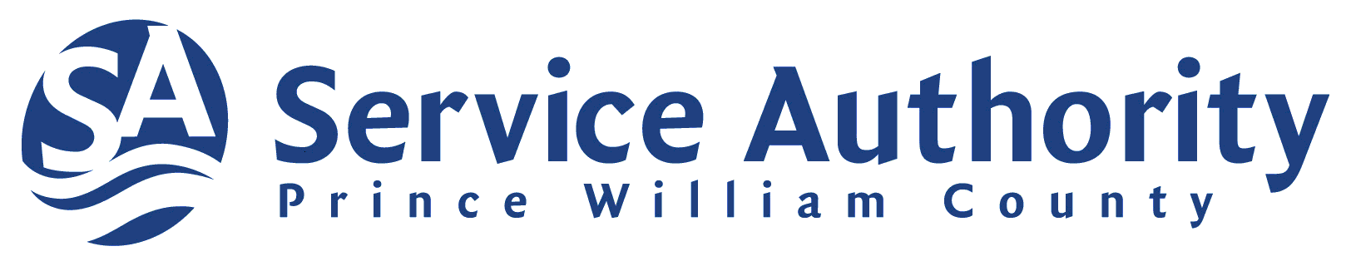

**FOR IMMEDIATE RELEASE CONTACT: Marcus Wilson**

May 2, 2024 **(703) 393-4407**

[**mwilson@pwcsa.org**](mailto:mwilson@pwcsa.org)

**Service Authority Celebrates National Drinking Water Week**

**WOODBRIDGE, VA, May 2, 2024** – The Prince William County Service Authority joins communities across North America in celebrating Drinking Water Week from May 5 to 11. Drinking Water Week highlights the importance of safe drinking water and recognizes the efforts of water professionals who keep water flowing 24/7 in our communities.

This year's commemoration coincides with a historic milestone – the 50th anniversary of the Safe Drinking Water Act (SDWA) in the United States, a landmark law designed to safeguard the public by setting high drinking water quality standards. The SDWA provides a scientific framework to identify potential risks to drinking water and address them in partnership with states and water utilities.

"Access to reliable, safe drinking water is vital to our daily health, hygiene and hydration," said Service Authority General Manager and CEO Calvin D. Farr, Jr., P.E. "Professionals at the Service Authority and throughout the water sector work tirelessly to ensure we have affordable access to the high-quality drinking water we need to protect public health and the environment—today and into the future."

To commemorate Drinking Water Week, water utilities, water organizations, government entities, environmental advocates, schools and others throughout North America and beyond are encouraging consumers to learn more about how water is protected, cleaned and delivered throughout their communities. If you are a Service Authority customer, you can learn more about your water at [www.pwcsa.org](http://www.pwcsa.org).

"Drinking Water Week is the perfect time to reflect on all that safe drinking water means in our lives,” said AWWA CEO David LaFrance. “Safe, reliable drinking water is critical in many ways, including public health, economic prosperity and our high quality of life. With the Safe Drinking Water Act anniversary, we also celebrate the committed water system workers, the vigilant regulators, the researchers, the public health professionals, the environmental advocates, and everyone with a hand in fulfilling the high standards and spirit of the SDWA."

###

*The Service Authority provides drinking water and wastewater services to approximately 386,000 people in homes, schools and businesses throughout Prince William County.*