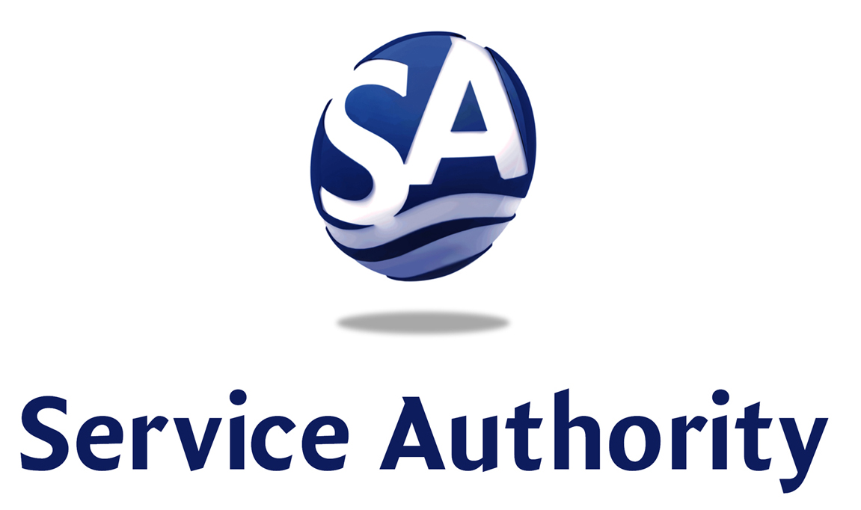
4 County Complex Court
P. O. Box 2266
Woodbridge, VA 22195-2266

Phone (703) 335-7900
Fax (703) 335-7905 www.pwcsa.org

K. Jack Kooyoomjian, Ph.D., Chairman
Joyce P. Eagles, Vice Chairman
Marlo Thomas Watson, Secretary-Treasurer
Jim Almond, Member
Paul Colangelo, Jr., Member
Dean E. Dickey, Member
B. Paul O’Meara, Jr., Member
Harry W. Wiggins, Member

Calvin D. Farr, Jr., P.E., General Manager

PWCSA BOARD OF DIRECTORS
Meeting Agenda – Thursday, September 9, 2021
6:45 PM
BOARD ROOM

1. CALL TO ORDER and GENERAL MATTERS 6:45
a) Consideration of Approval of Minutes of July 8, 2021 Meeting
b) Consideration of Approval of Minutes of July 27, 2021 Water Source and
Supply Alternatives Work Session
c) Consideration of Announcements by Staff
d) Citizens’ Time

2. PRESENTATION/ COMMENDATION 6:50
- Presentation: NACWA Platinum 12 Award
- Commendation: Donna Felch

3. ACTION MATTERS 6:55
a) Design-Build Services for H.L. Mooney Advanced Water Reclamation Facility
Wide Improvements:
i. Approval of Agreement Between Owner and Design-Builder on the Basis of Cost-Plus Contract
SA-2101A Preliminary Stage: 80% Design Documents and Preparation of Guaranteed Maximum
Price – Completion Stage with Ulliman Schutte Construction, LLC for the H.L. Mooney Advanced
Water Reclamation Facility Wide Improvements Project.
ii. Approval of Agreement SA-2104 With AECOM Technical Services, Inc. for Owner’s Consultant
Professional Services for Design-Build Services for the H.L. Mooney Advanced Water Reclamation
Facility Wide Improvements Project.
b) Issue a Work Order to AM-Liner East, Inc. for Sanitary Sewer Main Lining using Cured-In-Place Pipe (CIPP).
c) Approval of Task Order No. 7 to GHD, Inc. to Provide Professional Engineering Design Services for
Preparation of Preliminary Engineering Reports for Hooes Run Sewage Pumping Station, L01;
Dawson’s Landing Sewage Pumping Station, L51; Melrose Sewage Pumping Station, L10; and
Yorkshire Sewage Pumping Station, L30.

4. GENERAL MANAGER’S REPORT

5. ATTORNEY’S TIME

6. CONSIDERATION OF MATTERS PRESENTED BY MEMBERS

7. ADMINISTRATIVE REPORTS
a) CIP Status Report
b) H.L. Mooney Advanced Water Reclamation Facility Operating Results
c) Revised June 2021 Monthly Financial and Operational Report
d) Monthly Financial and Operational Report

8. CLOSED MEETING

9. ELECTIONS

10. ADJOURNMENT

